

**PHYSICS LAB**

**(20147)**

**Experiment No. 2**

**Basic Measurements**

**A. Vernier Caliber  
B. Micrometer Caliper**

**Name: ……………………………………. Reg. No. ( )**

**Partner name:……………………………….. Class ( )**

**Date / / 2021 Mark ( )**

**2007**

1. Objectives:

___________________________________________________________________________________________________________________________  
  
2. Apparatus

__________________________________________________________________________________

**Sample:**

3. Data:  
A. The Vernier Caliber   
Complete the following table

Table 1: Diameter of a thin tube

|  |  |  |  |
| --- | --- | --- | --- |
| NO. | Main Scale  mm | Vernier Scale  mm | Diameter  mm |
| 1. |  |  |  |
| 2. |  |  |  |
|  |  | Mean value = |  |

Table 2: Diameter of a thick tube.

|  |  |  |  |  |  |
| --- | --- | --- | --- | --- | --- |
| Term | | Main Scale  mm | Vernier Scale  mm | Count Value  mm | Mean Value  mm |
| Outside Diameter | 1. |  |  |  |  |
| 2. |  |  |  |  |
| Inside Diameter | 1. |  |  |  |  |
| 2. |  |  |  |  |
| Length | 1. |  |  |  |  |
| 2. |  |  |  |  |

a) Measure the mass of the tube using the electronic balance.

_______________________________________________________________

b) Calculate the average internal volume of the tube   
_____________________________________________________________________________________________________________________________________________________________________________________________  
  
c) Calculate the density of the material of the tube in SI-units  
_____________________________________________________________________________________________________________________________________________________________________________________________

B. The Micrometer Caliber   
  
Complete the following tables

Table 3. Diameter of different wires.

|  |  |  |  |  |  |
| --- | --- | --- | --- | --- | --- |
| Term | | Main Scale  mm | Vernier Scale  mm | Count Value  mm | Mean Value of  mm |
| Thick wire | 1. |  |  |  |  |
| 2. |  |  |  |  |
| Mid. wire | 1. |  |  |  |  |
| 2. |  |  |  |  |
| Thin wire | 1. |  |  |  |  |
| 2. |  |  |  |  |

Table 4: Thickness of a plate.

|  |  |  |  |
| --- | --- | --- | --- |
| NO. | Main Scale  mm | Vernier Scale  mm | Thickness  mm |
| 1. |  |  |  |
| 2. |  |  |  |
|  |  | Mean value= |  |

**4.** **Questions**

1) The Figure below shows a new Vernier that differ than the one used in our lab

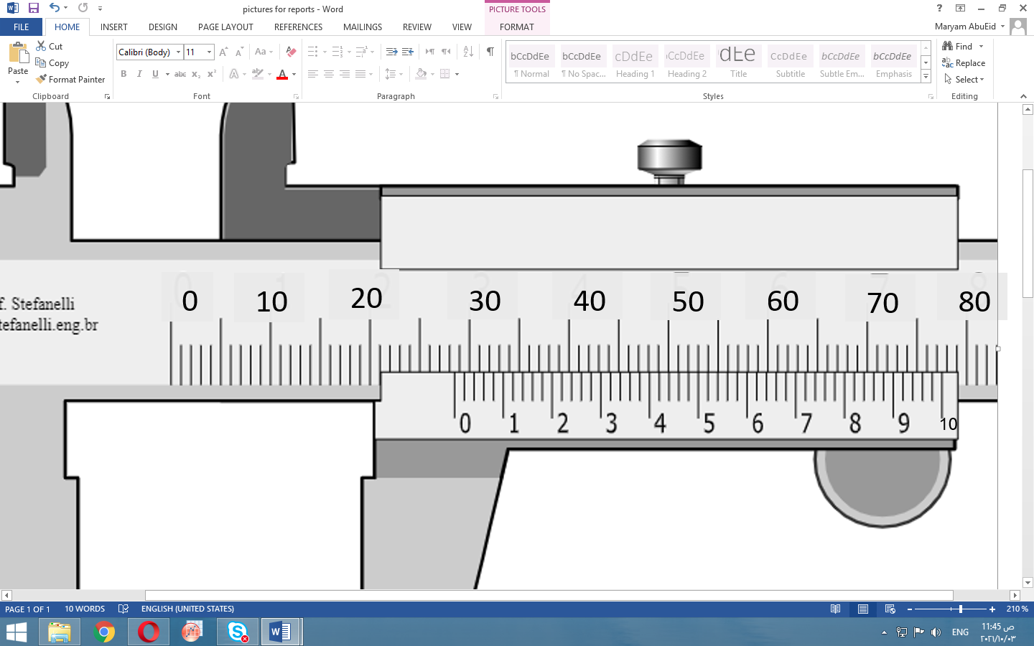

a) Determine the least count of this vernier.

_____________________________________________________________________________________________________________________________________________________________________________________________

b) Write the reading of this vernier.

|  |  |  |
| --- | --- | --- |
| Main reading (mm) | Vernier reading (mm) | Count Value (mm) |
|  |  |  |

c) What is the error in the reading of this Vernier?  
______________________________________________________________________________________________________________________________

2) One measurement for thickness of a plate was taken using micrometer and shown below

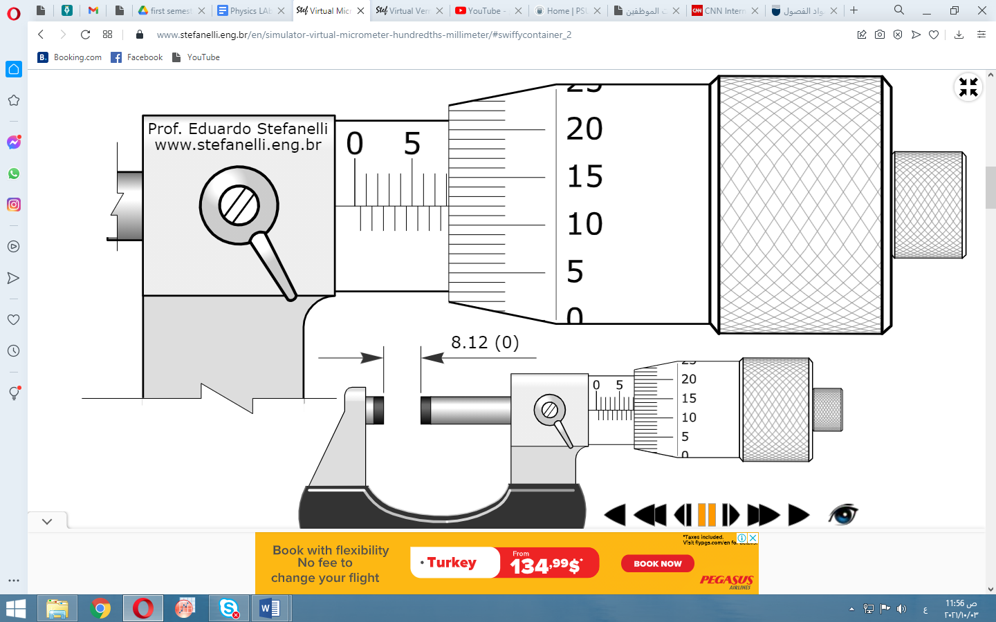

a) Write the reading of this micrometer.

|  |  |  |
| --- | --- | --- |
| Main reading (mm) | Vernier reading (mm) | Count Value (mm) |
|  |  |  |

b) What is the thickness of the plate?   
_______________________________________________________________

c) What is the error of the thickness?  
_______________________________________________________________

d) The final answer of the thickness is ________________________________